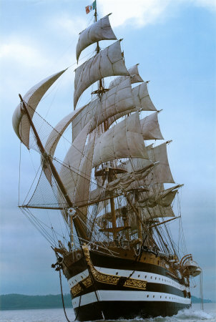
North West Maritime Limited
Coral Cove Marina, 125 Western Main Road
Chaguaramas, Trinidad W.I.
Phone: (868) 634 3135 Cell: (868) 680 1043
Email: operations@northwestmaritimeltd.com

STUDENT APPLICATION FORM

Date __________________________ Course ____________________________________

Form of Identification provided (type & number) ___________________________________

National ID Number ________

Name ________
(Last) (First) (Middle)

Address ________
(Number) (Street) (Box Number)

________
(City) (State) (Zip Code)

Telephone (Home) ______________ (Work) ______________________

Emergency Telephone ______________ Date of Birth

Current Merchant Marine Document or License Held ___
__________________

Current Employer ___
_____________________________________________________________________

E-mail Address ___

